**Air Quality and Weather App**

Submitted in partial fulfillment of the requirements

of the syllabus of

Android Apps Development Lab

in

Information Technology

by

SHETTY POOJA KARUNAKAR 118A3055

SELVAN MALVIKA ALLWINDURAI 118A3052

S SRIKRIPA 118A3057

Under the Guidance of:

Ms. Bushra Shaikh



Department of Information Technology

SIES Graduate School of Technology

2021-22

**CERTIFICATE**

This is to certify that the project entitled **“Air Quality and Weather App”** is a Bonafide work of the following students, submitted to the University of Mumbai in partial fulfillment of the requirement of the syllabus of **Android Apps Development Lab** in **Information Technology.**

**SHETTY POOJA KARUNAKAR 118A3055**

**SELVAN MALVIKA ALLWINDURAI 118A3052**

**S SRIKRIPA 118A3057**

Ms. Bushra Shaikh Dr. Lakshmi Sudha Dr. Atul N Kemkar

Internal Guide Head of Department Principal

**PROJECT REPORT APPROVAL**

This project report entitled ***Air Quality and Weather App*** by following students is approved for the requirement of the syllabus of ***Android Apps Development Lab*** in ***Information Technology.***

**SHETTY POOJA KARUNAKAR 118A3055**

**SELVAN MALVIKA ALLWINDURAI 118A3052**

**S SRIKRIPA 118A3057**

**Name of External Examiner: --------------------------------**

**Signature:--------------------------------**

**Name of Internal Examiner: --------------------------------**

**Signature:--------------------------------**

**Date:**

**Place:**

**DECLARATION**

I declare that this written submission represents my ideas in my own words and where others’ ideas or words have been included, I have adequately cited and referenced the original sources. I also declare that I have adhered to all principles of academic honesty and integrity and have not misrepresented or fabricated or falsified any idea/data/fact/source in my submission. I understand that any violation of the above will be cause for disciplinary action by the Institute and can also evoke penal action from the sources which have thus not been properly cited or from whom proper permission has not been taken when needed.

SHETTY POOJA KARUNAKAR 118A3055 _____________

SELVAN MALVIKA ALLWINDURAI 118A3052 _____________

S SRIKRIPA 118A3057 _____________

Signature

Date:

**ACKNOWLEDGEMENT**

It gives us immense pleasure to thank Dr. Atul N Kemkar, our Principal for extending his support to carry out and develop the project. We also thank our Head of Department Dr. Lakshmi Sudha for her support in completing the project. We wish to express our deep sense of gratitude and thank to our Internal Guide, Ms. Bushra Shaikh for her guidance, help and useful suggestions, which helped in completing our project work in time.

We would like to thank the entire faculty of Information Technology Department for their valuable ideas and timely assistance in this project, last but not least, we would like to thank our non-teaching staff members of our college for their support, in facilitating timely completion of this project.

**Project Team**

Shetty Pooja Karunakar

Selvan Malvika Allwindurai

S Srikripa

**ABSTRACT**

It is very much necessary to know exactly what is in the air you are breathing, you need to monitor the air where you are and also keep a check on the weather conditions. This app basically let's you check the live aur quality of the area that you are residing by detecting your live location and providing you the air index of that location and also allows you to search for a location and get to know the air quality of that particular region. Also there's a feature of comment section where users can provide their views on a particular area. Also this app allows you to keep a check on the weather condition of your present location or the searched location.

**Contents**

|  |  |  |
| --- | --- | --- |
|  |  | **Page No.** |
| **Chapter 1** | **Introduction** | **8** |
| **Chapter 2** | **Survey of Existing Apps** | **9** |
| **Chapter 3** | **Report on Present Investigation** | **10** |
|  | 3.1 Problem Statement | **10** |
|  | 3.2 Source of Problem Statement | **10** |
| **Chapter 4** | **Design and Implementation of Android Apps Components** | **11-14** |
|  | 4.1 Layouts | **11** |
|  | 4.2 Intents | **11** |
|  | 4.3 Activity | **12** |
|  | 4.4 Firebase | **12** |
|  | 4.5 Camera | **12** |
|  | 4.6 Firebase Cloud Messaging | **13** |
|  | 4.7 Multimedia | **13** |
|  | 4.8 Location API | **13** |
|  | 4.9 Generate APK file | **13-14** |
| **Chapter 5** | **Report on Proposed System and its Implementation** | **15-17** |
|  | 5.1 Block Diagram | **15-16** |
|  | 5.2 Flowchart | **17** |
|  | 5.3 Hardware | **17** |
| **Chapter 6** | **Results and Discussions** |  |
|  | 6.1 Summary of Screenshots with Navigational Flow |  |
| **Chapter 7** | **Conclusions** | **91** |
| **References** |  | **93** |

**Introduction**

Air pollution in India is a serious health issue. Of the 30 most polluted cities in the world, 21 were in India in 2019. As per a study based on 2016 data, at least 140 million people in India breathe air that is 10 times or more over the WHO safe limit and 13 of the world's 20 cities with the highest annual levels of air pollution are in India. 51% of the pollution is caused by industrial pollution, 27 % by vehicles, 17% by crop burning and 5% by fireworks. Air pollution contributes to the premature deaths of 2 million Indians every year. Emissions come from vehicles and industry, whereas in rural areas, much of the pollution stems from biomass burning for cooking and keeping warm. In autumn and spring months, large scale crop residue burning in agriculture fields – a cheaper alternative to mechanical tilling – is a major source of smoke, smog and particulate pollution. India has a low per capita emissions of greenhouse gases but the country as a whole is the third largest greenhouse gas producer after China and the United States. A 2013 study on non-smokers has found that Indians have 30% weaker lung function than Europeans.

To know exactly what is in the air you are breathing, you need to monitor the air where you are. This can be done with the help of our app. You will get to know the air quality index of the air of your current location. Using the camera you can take images of that location. Also you can view others comments and photos related to that location.

**Survey on Existing Apps**

**1. EPA’s AIRNow**

EPA's AirNow mobile app provides a simple interface for quickly checking current and forecast air quality information for planning daily activities and protecting your health. The app automatically displays the current AQI (Air Quality Index) for your local area or any area you wish to check, and allows you to store multiple areas for quick reference.

Features

* 1. Displays Current AQI for your local area or any area you wish to check.
* 2. Allows to store multiple areas for quick reference.

**2. IQAir AirVisual | Air Quality**

The most trusted and reliable air quality information brought to you from the world’s leading air pollution data provider. Covering 10,000+ locations from a global network of government monitoring stations and AirVisual’s own validated sensors.

Features

* 1. Historical, Real-time, and Forecast Air Pollution Data: detailed figures on key pollutants and AQI for over 10,000+ locations in 100+ countries, made clearly understandable. Follow air pollution trends with enhanced month-long and 48h historical views for your favorite locations.
* 2. Leading 7-Day Air Pollution and Weather Forecast: for the first time, plan your outdoor activities for the healthiest experiences a whole week ahead. Wind direction and speed forecasts to understand the wind’s impact on pollution.

**3. Flow – Air Pollution Sensor**

The Flow companion app from Plume Labs collects and analyses the data taken from your Flow’s PM2.5, PM10, NO2 and VOC sensors and gives you beautiful, easy-to-read reports, maps, and graphs.

Features

* 1. Track your personal pollution exposure with live data and daily reports
* 2. Avoid the most polluted places: Flow tracks air pollution variations around you in real time, so you can find clean air.

**Report on Present Investigation**

**3.1) Problem Statement:**

In today’s world, pollution has become a huge problem. So to keep a check on the quality of the air we are breathing in, we have developed a air quality checker app wherein you can get the air quality index of the current location and also the location of your choice. At the same time an additional feature would be to keep a check on the weather of the required/current location. Also we have a comment section wherein you will get to see people’s opinion and photographs of that location, so that you will get a clear picture of the pollution that exists at any place.

**3.2) Source of Problem Statement:**

This problem statement we got after searching numbers of research papers and also through our own thinking and discussions.

**Design and Implementation of Android Apps Components**

**4.1) Layouts**

A layout defines the structure for a user interface in your app, such as in an activity. All elements in the layout are built using a hierarchy of View and ViewGroup objects. A View usually draws something the user can see and interact with. Whereas a ViewGroup is an invisible container that defines the layout structure for View and other ViewGroup objects.

For our application we used Drawer layout, linear layout and constraint layout for customization of inner components wherever needed.

**4.2) Intents**

An Intent is a simple message object that is used to communicate between android components such as activities, content providers, broadcast receivers and services. Intents are also used to transfer data between activities.

Use of Intent

• For Launching an Activity

• To start a New Service

• For Broadcasting Messages

• To Display a list of contacts in ListView

Intent is of two types:

• Implicit Intent

• Explicit Intent

Implicit Intent

The implicit intent is the intent where instead of defining the exact components, you define the action that you want to perform for different activities.

An Implicit intent specifies an action that can invoke any app on the device to be able to perform an action. Using an Implicit Intent is useful when your app cannot perform the action but other apps probably can and you’d like the user to pick which app to use.

Explicit Intent

An explicit intent is an Intent where you explicitly define the component that needs to be called by the Android System. An explicit intent is one that you can use to launch a specific app component, such as a particular activity or service in your app.

**4.3) Activity**

An activity is a single, focused thing that the user can do. Almost all activities interact with the user, so the Activity class takes care of creating a window for you in which you can place your UI with setContentView(View). While activities are often presented to the user as full-screen windows, they can also be used in other ways: as floating windows (via a theme with R.attr.windowIsFloating set), Multi-Window mode or embedded into other windows.

Activity Lifecycle :

Activities in the system are managed as activity stacks. When a new activity is started, it is usually placed on the top of the current stack and becomes the running activity -- the previous activity always remains below it in the stack, and will not come to the foreground again until the new activity exits. There can be one or multiple activity stacks visible on screen.

**4.4) Database**

SQLite is a opensource SQL database that stores data to a text file on a device. Android comes in with built in SQLite database implementation.SQLite supports all the relational database features. In order to access this database, you don't need to establish any kind of connections for it like JDBC,ODBC e.t.c

Database - Package

The main package is android.database.sqlite that contains the classes to manage your own databases

Database - Creation

In order to create a database you just need to call this method openOrCreateDatabase with your database name and mode as a parameter. It returns an instance of SQLite database which you have to receive in your own object.

For our app purpose, we have used the database to store the login credentials of the user who register in our app. Also to store the comments of the people and the images of the location, we have used the database.

**4.5) Camera**

The Android framework includes support for various cameras and camera features available on devices, allowing you to capture pictures and videos in your applications. This document discusses a quick, simple approach to image and video capture and outlines an advanced approach for creating custom camera experiences for your users.

For our apps, we have used the camera to capture images of the locations if people want to add any.

**4.6) Location API**

One of the unique features of mobile applications is location awareness. Mobile users take their devices with them everywhere, and adding location awareness to your app offers users a more contextual experience. The location APIs available in Google Play services facilitate adding location awareness to your app with automated location tracking, geofencing, and activity recognition.

For our application, we have used the location API, in order to track down the current location of the user and thus display the Air quality index of the current location.

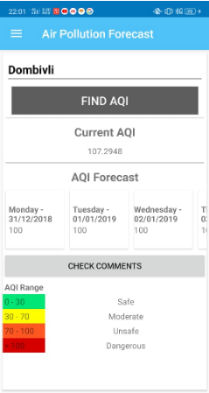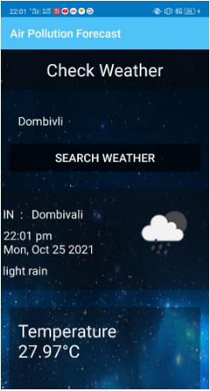

**4.10) Generate APK**

Android requires that all APKs be digitally signed with a certificate before they are installed on a device or updated. If you use Android App Bundles, you need to sign only your app bundle before you upload it to the Play Console, and app signing by Google Play takes care of the rest. However, you can also manually sign your app for upload to Google Play and other app stores.

This page guides your through some important concepts related to app signing and security, how to sign your app for release to Google Play using Android Studio, and how to opt in to app signing by Google Play.

The following is a high-level overview of the steps you might need to take to sign and publish a new app to Google Play:

• Generate an upload key and keystore

• Sign your app with your upload key

• Opt in to app signing by Google Play

• Upload your app to Google Play

• Prepare & roll out release of your app

If instead your app is already published to the Google Play Store with an existing app signing key, or you would like to choose the app signing key for a new app instead of having Google generate it, follow these steps:

• Sign your app with your app’s signing key and select the option to encrypt and export its signing key.

• Upload your app’s signing key to opt in to app signing by Google Play

• (Recommended) Generate and register an upload certificate for future updates to your app

• Upload your app to Google Play

• Prepare & roll out release of your app

**Report on Proposed System and its Implementation**

**Block Diagram:**

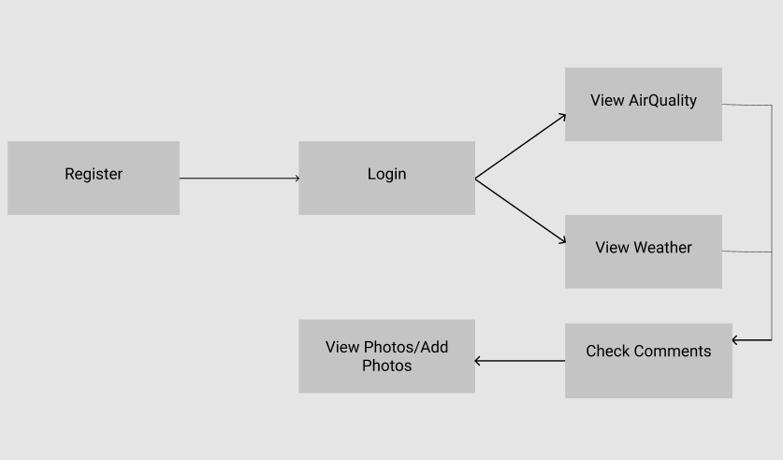

**Fig.1**

**Flowchart:**

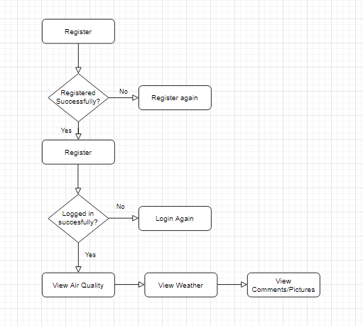

**Fig.2**

**Hardware –**

* Android Device
* GPS
* Internet
* Camera

**Results and Discussions :**

**Module A:**

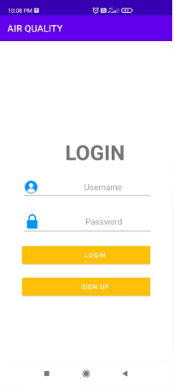 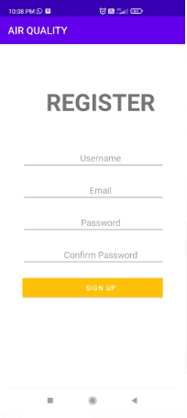

**Fig.3** **Fig**.**4**

To use our app, the user will first register himself/herself. Those credentials will be saved in the database. After that, the user can login using the credentials to the app.

**Module B:**

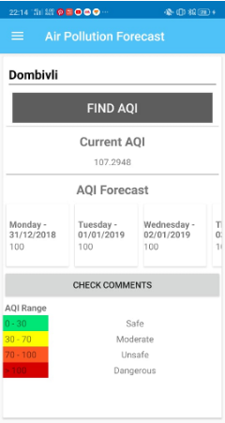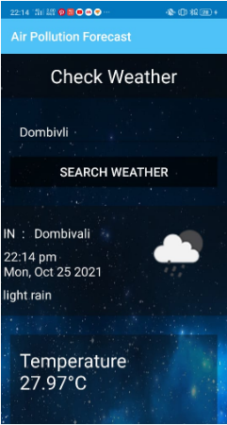

**Fig.5 Fig.6**

This is the second module, wherein after sign-in the user will be directed to. Here the user will get to see the Air Quality Index of the current location and the weather forcast of the current location.

**Module C:**

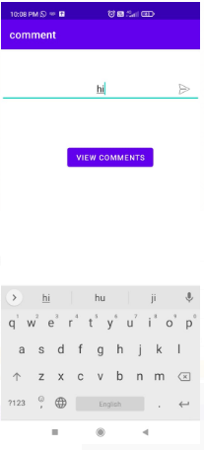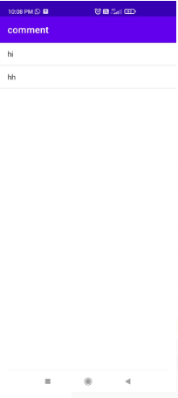

**Fig.7 Fig.8**

The comment section, wherein user can add his comments regarding that location or also view comments that has been put by others.

**Conclusion**

We have successfully created Air quality and weather checker application to keep track of the air quality and the weather conditions in your area and also the preferred location that you wish to search for.

**References**

1. https://w3points.com/android-tutorial/
2. https://www.youtube.com/watch?v=JAEldfC6b-c&list=PLj76U7gxVixSZIec8QSQCxHONZTZbQheG
3. https://www.iqair.com/in-en/air-pollution-data-api.
4. https://openweathermap.org/appi